Data Structure
______________________________________________

Q. what is data structure?
Data structure means to organize data in memory and manage their relationship for getting optimum solution called as data structure

Types of Data structure
____________________________________________________
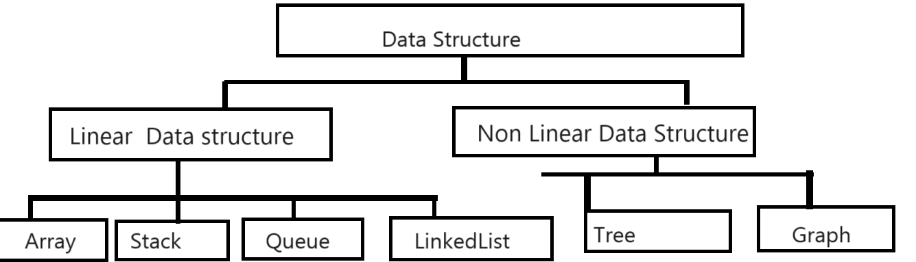

Array
____________________________________________________
Array is a collection of similar type of data
Syntax: data type variablename[5];
Example: int a[5];

Example: WAP to declare array of size 6 and store 5 values in it and input the index and value and store value on specified index in array and shift other index by +1
1. START
2. Declare array
3. Input initial value n-1
4. Ask index and value
5. Shift all values from index
6. Store value on index
7. STOP

Example
#include<stdio.h>
int main(){
int a[6],size,i,index,value;
printf("\nEnter values in arrayn\n");
size=sizeof(a)/sizeof(a[0]);
for(i=0; i<(size-1);i++){
scanf("%d",&a[i]);
}
printf("\nDisplay before insert\n");
for(i=0;i<size;i++){
printf("a[%d]----%d\n",i,a[i]);
}
printf("\nEnter index and value\n");
scanf("%d %d",&index,&value);
for(i=(size-2);i>=index;i--){
a[i+1]=a[i];
}
a[index]=value;
printf("\ndisplay after insert\n");
for(i=0;i<size;i++){
printf("a[%d]----%d\n",i,a[i]);
}

return 0;
}
malloc: malloc is function which is used for allocate dynamic memory normally malloc help us for two purpose
1. allocate memory at run time
2. create dynamic array in c language
Syntax:
pointervariable=(void*)malloc(size);
Note: if we want to work with malloc before malloc we need to void * pointer
Q. what is void* pointer?
__________________________________________________
void is pointer which is able to store any type of address just we need to cast appropriate type.

Example:
#include<stdio.h>
#include<stdlib.h>
int main(){
int *ptr,size,i,index,value;
printf("\nEnter size of array\n");
scanf("%d",&size);
ptr=(int*)malloc(sizeof(int)*size);
printf("Enter values in array\n");
for(i=0;i<(size-1);i++){
scanf("%d",&ptr[i]);
}
printf("\nBefore insert\n");
for(i=0;i<size;i++){
printf("a[%d]--->%d\n",i,ptr[i]);//base address+index*size
}
printf("\nEnter index and value\n");
scanf("%d %d",&index,&value);
for(i=(size-2);i>=index;i--){
ptr[i+1]=ptr[i];
}
ptr[index]=value;
printf("\nAfter insert\n");
for(i=0;i<size;i++){
printf("a[%d]--->%d\n",i,ptr[i]);
}
return 0;
}
Array implementation
________________________________________________
Stack
_________________________________________________
Stack is a data structure which is used for maintain data in last in first out format and it is single ended data structure and it has one pointer name as top which is initially -1 and when we insert data in stack top increase by 1 and we delete data from stack then top decrease by 1

There are three types of operation perform on stack.
1. PUSH: when we insert data in stack called as push operation and when we insert data in stack then top increase by 1.
In the case of push operation there is possibility stack overflow condition means when we have stack and there is no space for new element called as stack overflow

2. POP: POP operation means we remove element from stack and when we remove element from stack then top decrease by 1 and in the case of stack there is one condition called as stack is underflow Means when your stack is totally empty called as stack is underflow.
Algorithm for push
______________________________________________
a) Set top=-1
b) Declare array
c) Check top ==MAX-1
Stack is overflow
d) Otherwise increase top by 1
e) Insert data in stack
stack [top=value
f) Repeat step C d and e until stack is overflow or full.
g) Stop.

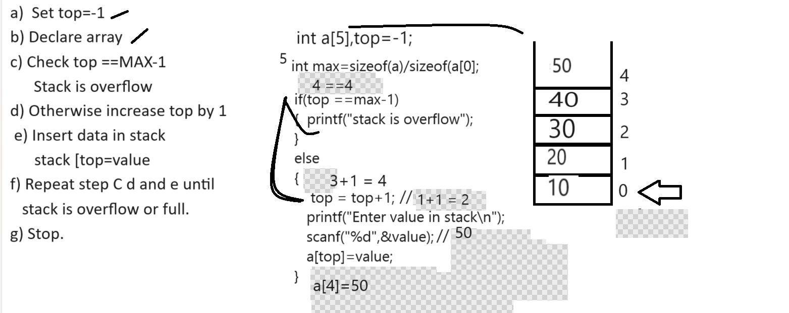
Algorithm for POP
a) set top=-1
b) check top ==-1
printf(“stack is underflow”);
c) otherwise extract data from stack
d) decrease top by 1
e) repeat step b,c,d until stack is underflow.
f) stop

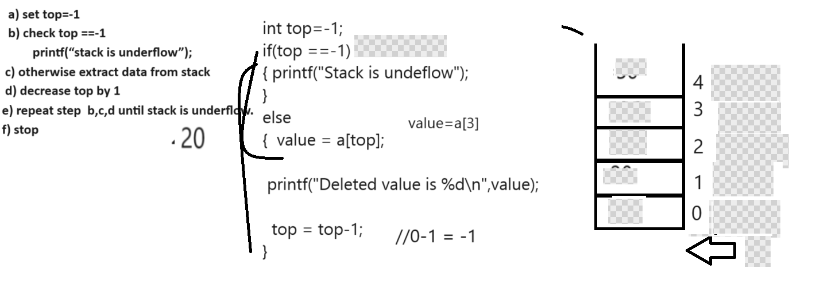
3. Display: display stack data
#include<stdio.h>
#include<stdlib.h>
int top=-1;
int a[5];
int max=sizeof(a)/sizeof(a[0]);
void push(int e){
if(top==max-1){
printf("Stack is overflow");
}
else{
top = top +1;
a[top]=e;
}
}
void pop(){
if(top==-1){
printf("STack is underflow");
}
else{
int value=a[top];
printf("\ndeleted value is %d\n",value);
top=top-1;
}
}
void display(){
for(int i=top;i>=0;i--){
printf("%d\t",a[i]);
}
}
int main(){
int choice,value;
do{
printf("1:PUSH\n");
printf("2:POP\n");
printf("3:Display\n");
printf("Enter your choice\n");
scanf("%d",&choice);
switch(choice){
case 1:
printf("\Enter value in stack\n");
scanf("%d",&value);
push(value);
break;
case 2:
pop();
case 3:
display();
break;
default:
printf("Wrong choice");
}
}while(choice!=4);
return 0;
}
Linear Search and Binary Search
__________________________________________________
Algorithm for linear Search
1. START
2. DECLARE ARRAY
3. Input Search key
4. Set flag =0
5. Compare search key value with every element in array
6. If value found then set flag=1 and break the loop
7.STOP
Example:
#include<stdio.h>
int main(){
int a[5],i,flag=0,skey;
printf("\nenter five values in array\n");
for(i=0; i<5; i++){
scanf("%d",&a[i]);
}
printf("Enter Search key\n");
scanf("%d",&skey);
for(i=0;i<5;i++){
if(a[i]==skey){
flag=1;
break;
}
}
if(flag){
printf("Value found");
}
else{
printf("Value not found");
}
return 0;
}
Binary Search Algorithm
__________________________________________________
Binary Search algorithm work on only sorted data and in this we divide the array in two sections we find the mid element of array and compare search key with mid element and if search match with mid element then we declare value found if search key is less than of mid element then we search data in first half i.e at left hand side and if search key is greater than mid element then search data at right hand side

Source code
#include<stdio.h>
int main(){
int a[10],i,flag=0,skey,l,r,size;
printf("\nenter five values in array\n");
l=0;
size=sizeof(a)/sizeof(a[0]);
r=(size-1);
for(i=0; i<size; i++){
scanf("%d",&a[i]);
}
printf("Enter Search key\n");
scanf("%d",&skey);
while(l<=r){
int mid=l+(r-l)/2;
if(a[mid]==skey){
flag=1;
break;
}
if(a[mid]<skey){
l=mid+1;
}
else{
r=mid-1;
}
}
if (flag){
printf ("Value found");
}
else{
printf ("Value not found");
}
return 0;
}
Sorting Algorithm
_______________________________________________
1. Bubble sort
2. Selection sort
3. Merge sort
4. Heap
5. Quick Sort
etc

Bubble sort: bubble sort algorithm means we compare the two values with each other means previous index value with next index value and compare if previous index value with greater than next index then performs swapping between them means next index value set on previous and previous value set on next.

#include<stdio.h>
int main(){
int a[5],i,j,temp;
printf("\nEnter five values in array\n");
for(i=0;i<5;i++){
scanf("%d",&a[i]);
}
printf("\nDisplay array before values\n");
for(i=0;i<5;i++){
printf("%d\t",a[i]);
}
//apply sorting logics
for(i=0;i<5;i++){
for(j=(i+1);j<5;j++){

if(a[i]>a[j]){
int temp=a[i];
a[i]=a[j];
a[j]=temp;
}
}
}
printf("\nDisplay array after values\n");
for(i=0;i<5;i++){
printf("%d\t",a[i]);
}
return 0;
}

Example: WAP to store the 5 values and find the second highest value from array

#include<stdio.h>
int main(){
int a[5],i,j,temp;
printf("\nEnter five values in array\n");
for(i=0;i<5;i++){
scanf("%d",&a[i]);
}
printf("\nDisplay array before values\n");
for(i=0;i<5;i++){
printf("%d\t",a[i]);
}
//apply sorting logics
for(i=0;i<5;i++){
for(j=(i+1);j<5;j++){

if(a[i]>a[j]){
int temp=a[i];
a[i]=a[j];
a[j]=temp;
}
}
}
printf("\nDisplay array after values\n");
int count=4,count1=0;
for(i=0;i<5;i++){
printf("%d\t",a[i]);
if(a[count]==a[i]){
++count1;
}
}
printf("\nSecond highest value is %d\n",a[4-count1]);
return 0;
}

Example: WAP to input two arrays and check array is anagram
Array or not

a= [1 3 2 4 5]
b= [1 4 3 2 5]

Example: WAP to input 10 values in array and find the occurrence of every value
10 20 30 10 20 30 10 20 30 10

10 – 4
20 – 3
30 – 3

#include<stdio.h>
int main(){
int a[10],i,j,temp;
printf("\nEnter five values in array\n");
for(i=0;i<10;i++){
scanf("%d",&a[i]);
}
printf("\nDisplay array before values\n");
for(i=0;i<10;i++){
printf("%d\t",a[i]);
}
//apply sorting logics
for(i=0;i<10;i++){
for(j=(i+1);j<10;j++){

if(a[i]>a[j]){
int temp=a[i];
a[i]=a[j];
a[j]=temp;
}
}
}
printf("\nDisplay array after values\n");
int count=1;
for(i=0;i<10;i++){
if(a[i]==a[i+1]){
++count;
}
else{
printf("%d ---->%d\n",a[i],count);
count=1;
}
}

return 0;
}

